# Project Planning Template

Project Planning Phase  
(Project Backlog, Sprint Planning, Stories, Story points)

Date: 24 june 2025

Team ID:LTVIP2025TMID43376

Project Name: Pattern Sense: Classifying Fabrics Using Deep Learning

Maximum Marks: 5 Marks

## Product Backlog, Sprint Schedule, and Estimation (4 Marks)

🔄 1. Product Backlog (Epics → User Stories)

|  |  |  |  |
| --- | --- | --- | --- |
| Epic | User Story | Priority | Estimation |
| Data Collection | As a developer | I want to gather a labeled dataset of fabric images by pattern type. | High  8 |
| Data Preprocessing | As a developer | I want to preprocess images (resize, normalize, augment) for training | High  5 |
| Model Development | As a data scientist | I want to train a CNN model to classify fabric patterns. | High  8 |
| Model Evaluation | As a data scientist | I want to evaluate the model using accuracy, precision, and recall. | High  5 |
| Model Optimization | As a developer | I want to tune hyperparameters to improve model performance. | Medium  5 |
| Web Interface | As a user | I want to upload a fabric image and see the predicted pattern type. | Medium  8 |
| Backend Integration | As a developer | I want to expose the model inference via a REST API. | Medium  5 |
| Deployment | As a devops engineer | I want to deploy the model and web app to a cloud platform (e.g., AWS). | Medium  8 |
| Documentation | As a team member | I want to provide documentation for training, API usage, and deployment steps. | Medium  5 |
| Testing | As a QA engineer | I want to implement unit tests and user testing to ensure functionality. | Medium  5 |

🗓️ 2. Sprint Schedule (4 Sprints – 1 Week Each)

Sprint 1: Data Pipeline Setup

Dataset sourcing or creation (Story Points: 8)

Image preprocessing & augmentation (5)

Initial EDA (exploratory data analysis)

Total Points: 13

Sprint 2: Model Development

CNN model development and training (8)

Model evaluation & validation (5)

Total Points: 13

Sprint 3: App & API

Create REST API (Flask/FastAPI) (5)

Develop web UI for file upload & results (8)

Basic testing (2)

Total Points: 15

Sprint 4: Final Touch & Deployment

Hyperparameter tuning / retraining (5)

Deploy model and UI to cloud (8)

Documentation & README (3)

Final testing & bug fixes (2)

Total Points: 18

⏱️ 3. Estimation Summary

Task Type Total Story Points

Core ML Tasks 26

Web/API/Backend 18

Testing & Docs 10

Total 54 Points (~54–60 hours effort for a small team of 2–3 people)**

## Project Tracker, Velocity & Burndown Chart (4 Marks)

Sprint | Total Story Points | Duration | Sprint Start Date | Sprint End Date (Planned) | Story Points Completed (as on Planned End Date) | Sprint Release Date (Actual)

Sprint-1 | 10 | 6 Days | 01 june 2025 | 06 june 2025 | 10 | 06 june 2025  
Sprint-2 | 8 | 6 Days | 07 june 2025 | 12 june 2025 | 8 | 12 june 2025  
Sprint-3 | 8 | 6 Days | 13 june 2025 | 18 june 2025 | |

## Velocity

Sprint Velocity = Total Story Points / Sprint Duration

Example: Sprint-1: 10 points / 6 days = 1.67 points/day

## Burndown Chart

A burndown chart shows the remaining work in the sprint backlog against time. It's used to track sprint progress.

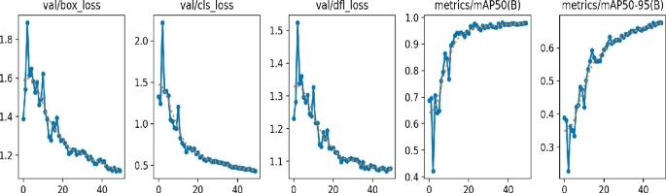

## References

https://www.atlassian.com/agile/project-management  
https://www.atlassian.com/agile/tutorials/how-to-do-scrum-with-jira-software  
https://www.atlassian.com/agile/tutorials/epics  
https://www.atlassian.com/agile/tutorials/sprints  
https://www.atlassian.com/agile/project-management/estimation  
https://www.atlassian.com/agile/tutorials/burndown-charts  
https://www.visual-paradigm.com/scrum/scrum-burndown-chart/